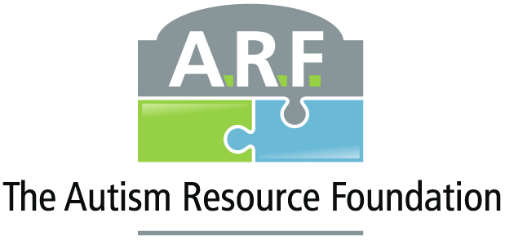
RESOURCES & INFORMATION:
- The Autism Resource Foundation, Inc “ARF”
  - The Autism Resource Foundation – Autism awareness, advocacy and resources in North Alabama & the Tennessee Valley Region.
- Autism Society of Alabama
  - https://www.autism-alabama.org/
- Making Connections – a support group for parents with children facing autism
  - https://www.rocketcitymom.com/making-connections-autism-support/
- Applied Behavioral Concepts
  - Our Services (appliedbehavioralconcepts.net)
- The Riley Center
  - The Riley Center – A Community of Hope
- Asperger Syndrome S. E. A. Beyond Tomorrow: Support, Educate, Advocate
  - (10) Asperger Syndrome S.E.A. Beyond Tomorrow: Support, Educate, Advocate | Facebook
- Asperger Education Services
  - Contact Angela Collier, M. Ed., at aspergereducationservices@gmail.com
TESTING CENTERS: ***Standard wait time to be seen **6 months (can be longer); you can ask to be put on their waiting list and continue to follow up to get status every few months.
- Silver Linings Neurodevelopment (local)
  - https://www.silverliningsclinic.com/
  - Phone: 256-489-1583
  - Address: 185 Chateau Dr SW Suite 102, Huntsville, AL 35801
- Hope Autism Clinic – *new location in Huntsville (2021), available for services; Illinois location Is for diagnostics
  - https://www.theautismclinic.org/apply-for-services/
  - (Main website) https://www.theautismclinic.org/
  - Toll Free: 866-5-ABA-HOPE
  - Main Address – for diagnostic services:
    - Hope Pavilion, 5220 S. Sixth Street, Suite 1700, Springfield, IL 62703
  - Local Address: 5767 Cove Commons Drive SE, Brownsboro, AL 65741
- Vanderbilt Kennedy Center “TRIAD” out of Nashville, TN; nationally recognized
  - TRIAD stands for Treatment and Research Institute for Autism Spectrum Disorders
  - https://vkc.vumc.org/vkc/triad/home/
  - Phone: 615-322-8240
  - Address: 110 Magnolia Cir, Nashville, TN 37203
- UAB “Sparks Center” out of Birmingham, AL; world renowned Medical Center
  - University Alabama at Birmingham, Civitan Sparks Clinic
  - Phone unavailable: must go to: https://www.uab.edu/civitansparks/appointments and fill out form then submit by email to: sbohannon@pds.uab.edu or mail to:
ATTN: Shannon Bohannon
CH 19; Suite 307
1720 2nd Ave South
Birmingham, AL 35294

