Trek Guide for Participants

Contents:
- Program Overview – Pages 2
- Point System – Page 3
- Trek Map – Page 3

Program Overview

- The purpose of the Great Outdoors Challenge is to challenge participants to walk, run, or hike* their way through a virtual trek across the United States. During this challenge, we encourage participants to take advantage of the great outdoors and exercise outside to meet their physical activity goals.
- The Great Outdoors Challenge is an individual challenge that will be held August 1st – 28th, 2022.
- The Challenge is a 4-week program in which the winner(s) will be determined by the most trekking (walk/run/hike) accumulated, represented as length traveled on the provided US landmark map. Walking, running, and hiking activities will translate into distance, which will accumulate throughout the challenge and progress everyone through their virtual journey across the US, passing through 48 states. Since this is a virtual trek, the winning individual(s) are determined by farthest virtual distance traveled over the 4 weeks.
- To play, download the following documents:
  - Program Overview
  - Trek Mile Marker Guide
  - Individual Trek Tracker for recording mileage
- Although this is an individual challenge, we encourage participants to invite family, friends, and/or colleagues to join you on this virtual trek across the US. **
- Everyone will calculate their own trek, even if others are accompanying them in the virtual Great Outdoors Challenge journey across the US.
- Certificates of Achievement will be awarded to all participants who finish the Great Outdoors Challenge and trek all the way across the US.
- Scores can be reported to info@millenniumhealthand fitness.com at the end of your trek!

* For those participants with special needs, modifications can be made in lieu of walking, running, and hiking. For example, if a client is in a wheelchair, they may utilize an ergometer.

** Please note that only registered participants’ distances will be recorded as eligible for the challenge.

Point System

Each trekker will track his/her cumulative minutes of walking, jogging, and/or hiking each day. Points will be earned based on the total number of minutes accumulated. The number of accumulated minutes of activity will be converted into “trekking miles” to calculate distance traveled throughout the week. There is no limit to the number of minutes of walking, jogging, and/or hiking a participant can accumulate in one day. GOAL: 35 minutes of activity per day.

Activity sample:
- Walked the dog in the morning for 10 minutes
- Jogged at lunch for 30 minutes
- Hiked with friends before dinner for 60 minutes
- Walked the dog in the evening for 10 minutes
- Total of 110 points for the day

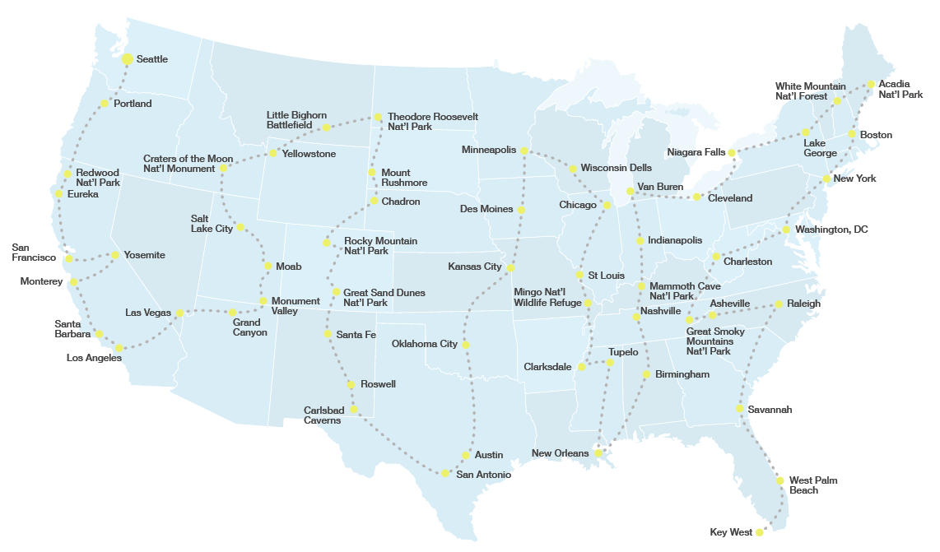
Trek Map:

